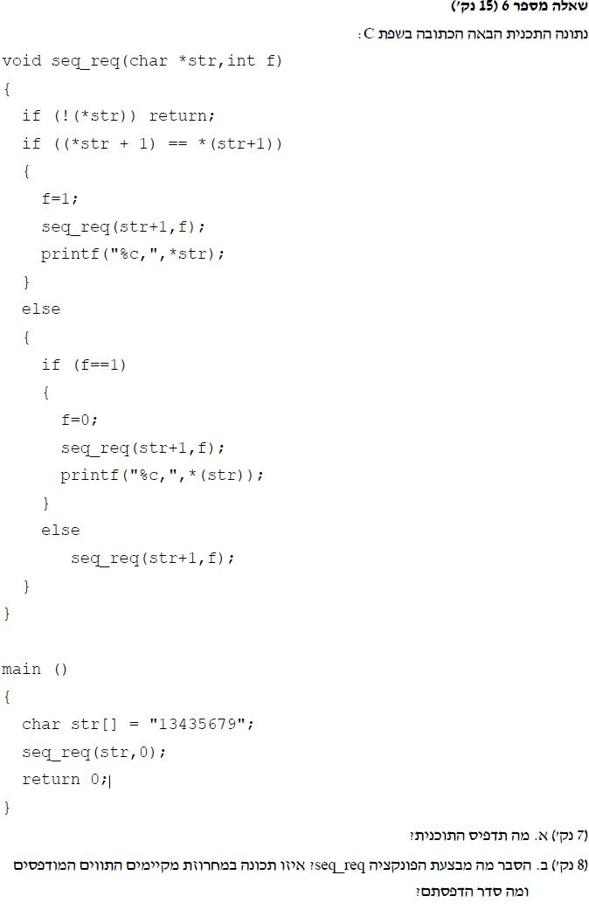

#include <stdio.h>

#define N 10

// Answer 5: What the program will do?

int main()

{

int vec[N] = { 1,4,6,8,9,11,14,16,18,19 };

int i, j, flag = 0;

int num;

for (i = 0; i < N; i++)

printf("%d,", vec[i]);

printf("\nenter number: ");

scanf("%d", &num)

i = 0; j = N - 1;

// If we find 2 numbers that adding them equal to num- flag == 1

while (!flag)

{

if (j <= i) flag = 2;

else if ((vec[i] + vec[j]) == num) flag = 1;

else if ((vec[i] + vec[j]) < num) i++;

else j--;

}

if (flag == 1) printf("Yes!!: %d %d\n", vec[i], vec[j]);

else printf("No!!\n");

return 0;

}